

**CAMPUS MUNCHIES**

**fast food management system**

**Software Design Specification**

– CanTho, Oct 2022 –

**Record of changeS**

| **Date** | **A* M, D** | **In charge** | **Change Description** |
| --- | --- | --- | --- |
| 24/9/2023 | A | KhoaDD | Added sequence diagrams of login for employee(III.5.c) |
| 24/9/2023 | A | KhoaDD | Added sequence diagrams of update profile for employee(III.6.c) |
| 24/9/2023 | A | KhoaDD | Added sequence diagrams of view list of orders for employee(III.7.c) |
| 24/9/2023 | A | KhoaDD | Added sequence diagrams of change order’s status for employee(III.8.c) |
| 24/9/2023 | A | KhoaDD | Added sequence diagrams of view order detail for employee(III.9.c) |
| 24/9/2023 | A | KhoaDD | Added sequence diagrams of view customer’s information for employee(III.10.c) |
| 24/9/2023 | M | KhangTM | Added code design view menu (III.1) and show cart (III.2) |
| 25/9/2023 | A | KhanhNN | Added sequence diagrams for manager(III.9) |
| 25/9/2023 | A | TienDS | Added sequence diagrams of register for guest(III.3.c) |
| 25/9/2023 | A | TienDS | Added sequence diagrams of register for guest(III.4.c) |
| 25/9/2023 | M | KhoaDD | Modified sequence diagrams of login for employee(III.5.c) |
| 25/9/2023 | M | KhangTM | Added code design add and delete food from cart (III.17.c) |
| 25/9/2023 | A | KhoaDD | Added Class Diagram(III.5.a), Diagram Specification(III.5.b), Database queries(III.5.d) login for employee. |
| 26/9/2023 | A | KhoaDD | Added a,b,d for III.6,7,8,9,10 for employee |
| 26/9/2023 | A | TienT | Added sequence diagrams of create order for guest(III.18.c) |
| 26/9/2023 | A | TienT | Added sequence diagrams of log out for customer(III.19.c) |
| 28/9/2023 | A | VuTT | Added Code Package(I.1) |
| 28/9/2023 | M | KhoaDD | Modified sequence diagrams of employee(III.5.c,6.c,7.c,8.c,9.c,10.c) |
| 29/9/2023 | A | KhoaDD, KhangTM | Added database schema(II.2.a) and table description(II.2.b) |
| 31/11/2023 | D | TienDS | Deleted Code Packages(I.1) |
| 01/11 | M | TienDS | Modified sequence Diagram(III) |

*A - Added M - Modified D - Deleted

**Table of Contents**

I. Overview 5

1. Code Packages 5

2. Database Design 8

a. Database Schema 8

b. Table Description 8

II. Use case diagram **10**

III. Code Designs 11

1. View Menu 11

a. Class Diagram 11

b. Class Specifications 11

c. Sequence Diagram(s) 12

d. Database Queries 12

2. Show cart 13

a. Database Queries 13

b. Class Specifications 13

c. Sequence Diagram(s) 14

d. Database Queries 14

3. Register for Guest 15

a. Class Diagram 15

b. Class Specifications 15

c. Sequence Diagram(s) 16

d. Database Queries 16

4. Show order history Customer 17

a. Class Diagram 17

b. Class Specifications 17

c. Sequence Diagram(s) 18

d. Database Queries 18

5. Login(Employee) 18

a. Class Diagram 18

b. Class Specifications 19

c. Sequence Diagram(s) 20

d. Database Queries 20

6. View list of orders(Employee) 20

a. Class Diagram 20

b. Class Specifications 20

c. Sequence Diagram(s) 21

d. Database Queries 21

7. Change order’s status(Employee) 22

a. Class Diagram 22

b. Class Specifications 22

c. Sequence Diagram(s) 23

d. Database Queries 23

8. View order detail(Employee) 23

a. Class Diagram 23

b. Class Specifications 23

c. Sequence Diagram(s) 24

d. Database Queries 24

9. View Analytics 25

a. Class Diagram 25

b. Class Specifications 25

c. Sequence Diagram(s) 26

d. Database Queries 26

10. Order Management 27

a. Class Diagram 27

b. Class Specifications 27

c. Sequence Diagram(s) 28

d. Database Queries 28

11. Customer management 29

a. Class Diagram 29

b. Class Specifications 29

c. Sequence Diagram(s) 30

d. Database Queries 30

12. Employee management 31

a. Class Diagram 31

b. Class Specifications 31

c. Sequence Diagram(s) 31

d. Database Queries 32

# I. Overview

## 1. Code Packages

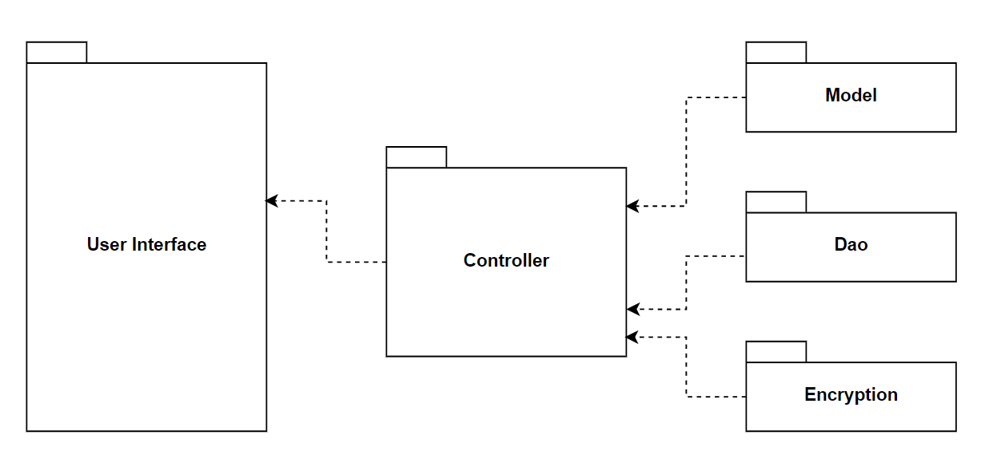

***Package descriptions***

| **No** | **Package** | **Description** |
| --- | --- | --- |
| **01** | **User interface** | This package is responsible for presenting the data to the user and receiving user input. |
| **02** | **Controller** | This package is responsible for managing the process of placing an order, account and redirect pages. |
| **03** | **Model** | This package contains models. |
| **04** | **DAO** | This package is responsible for accessing the items, order information, user information… form the database. |
| **05** | **Encryption** | This package provides an encrypt method to make the system more secure. |

## 2. Database Design

### a. Database Schema

### b. Table Description

| **No** | **Table** | **Description** |
| --- | --- | --- |
| 01 | Customer | - Description: The customer table stores all customer information.  - Primary keys: cus_id  - Foreign keys: none |
| 02 | Product | - Description: Contains foods and drinks in the shop  - Primary keys: pro_id  - Foreign keys: cat_id |
| 03 | Categories | - Description: Category of the food  - Primary keys: cat_id  - Foreign keys: none |
| 04 | Employee | - Description: The Employee table is used to store all information about employees.  - Primary keys: emp_id  - Foreign keys: none |
| 05 | Order | - Description: Orders of the customers and guests and show which employee managed this order  - Primary keys: ord_id  - Foreign keys: emp_id, cus_id |
| 06 | Order_Details | - Description: The Order_Details table is responsible for storing detailed information of an order.  - Primary keys: none  - Foreign keys: ord_id, pro_id |
| 07 | Manager | - Description: The managers of the shop  - Primary keys: username  - Foreign keys: none |
| 08 | Cart | - Description: The Cart table store food customer order  - Primary keys: none  - Foreign keys: foo_id, cus_phone |

# II. Use case diagram

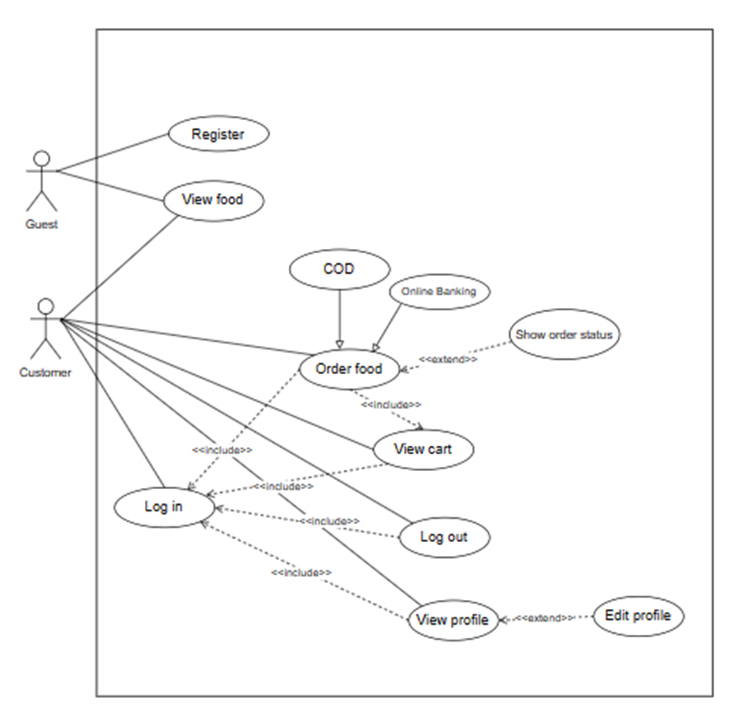

*Guests and customers use cases*

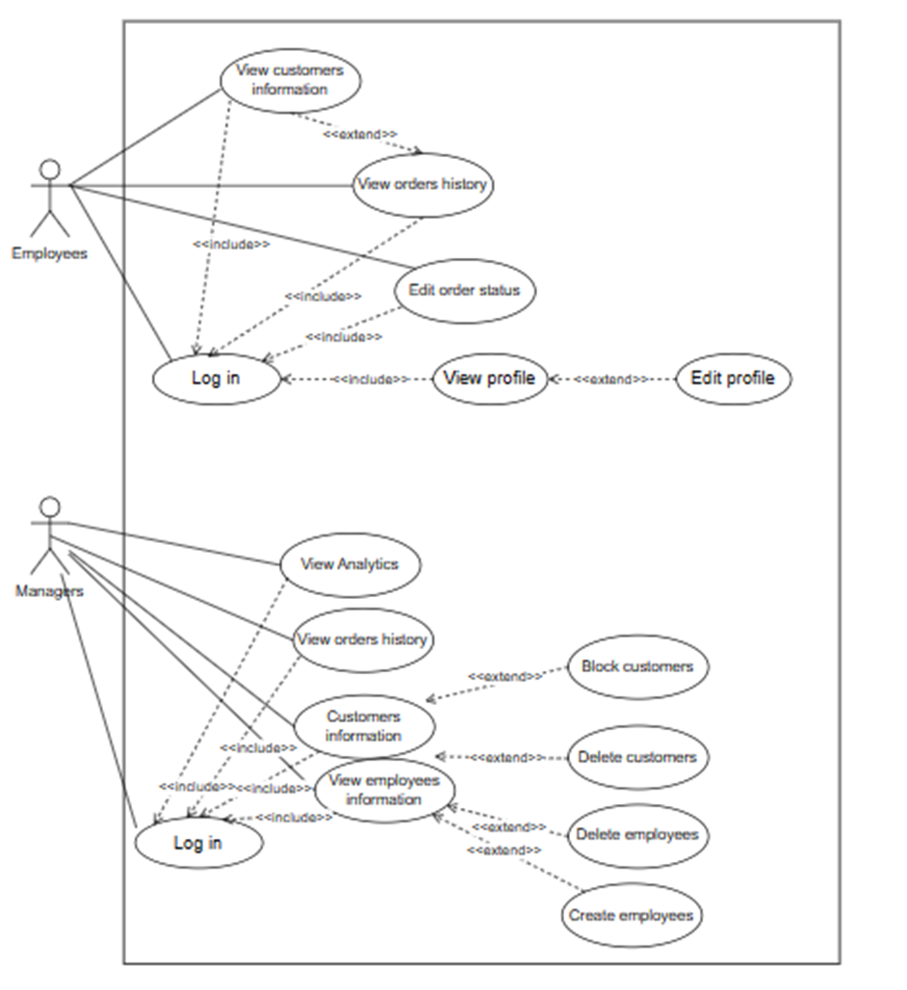

*Employees and managers use cases*

# III. Code Designs

## 1. View Menu

### a. Class Diagram

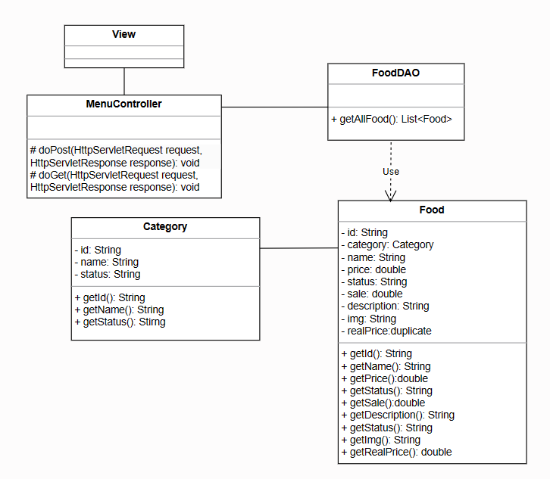

### b. Class Specifications

***FoodDAO***

| **No** | **Method** | **Description** |
| --- | --- | --- |
| 01 | List<Food> getAll Food | Get all food in the database, the food information will be put in a list |

***Food***

| **No** | **Method** | **Description** |
| --- | --- | --- |
| 01 | getId(): String | get the id of the food |
| 02 | getCategory(): Category | Get the category of the food |
| 03 | getName(): String | get the name of the food |
| 04 | getPrice(): double | get the unit price |
| 05 | getSale() | get the sale |
| 06 | getDescription() | get the description |
| 07 | getStatus() | get status |
| 08 | getImg() | get the image url |
| 09 | getRealPrice() | get the price after sale |
| 10 | getId(): String | Get category Id |
| 11 | getName(): String | get the category name |
| 12 | getStatus(): String | get tht status |

***MenuController***

| **No** | **Method** | **Description** |
| --- | --- | --- |
| 01 | doGet(HttpServletRequest request, HttpServletResponse response) | The doGet method helps navigate the corresponding page based on the results of the login method. |
| 02 | doPost(HttpServletRequest request, HttpServletResponse response) | The doPost method to get information from the view page, implement a register method and redirect to the corresponding page. |

### c. Sequence Diagram(s)

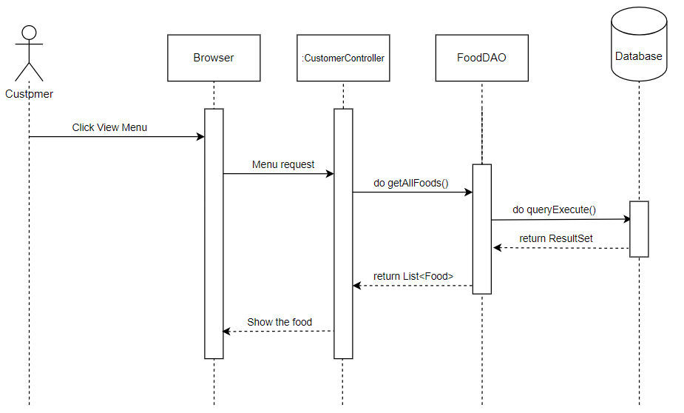

#### 

### d. Database Queries

SELECT * FROM Food where foo_id <> ‘Deleted’

SELECT * FROM Category WHERE cat_id = ?

## 2. Show cart

### a. Database Queries

### b. Class Specifications

***CartDAO***

| **No** | **Method** | **Description** |
| --- | --- | --- |
| 01 | getAll(String phone) | Get all food from cart by using phone number |

***Food***

| **No** | **Method** | **Description** |
| --- | --- | --- |
| 01 | getId(): String | get the id of the food |
| 02 | getCategory(): Category | Get the category of the food |
| 03 | getName(): String | get the name of the food |
| 04 | getPrice(): double | get the unit price |
| 05 | getSale() | get the sale |
| 06 | getDescription() | get the description |
| 07 | getStatus() | get status |
| 08 | getImg() | get the image url |
| 09 | getRealPrice() | get the price after sale |

### 

***CartController***

| **No** | **Method** | **Description** |
| --- | --- | --- |
| 01 | doGet(HttpServletRequest request, HttpServletResponse response) | The doGet method helps navigate the corresponding page based on the results of the login method. |
| 02 | doPost(HttpServletRequest request, HttpServletResponse response) | doPost method to get information from the view page, implement a register method and redirect to the corresponding page. |

### c. Sequence Diagram(s)

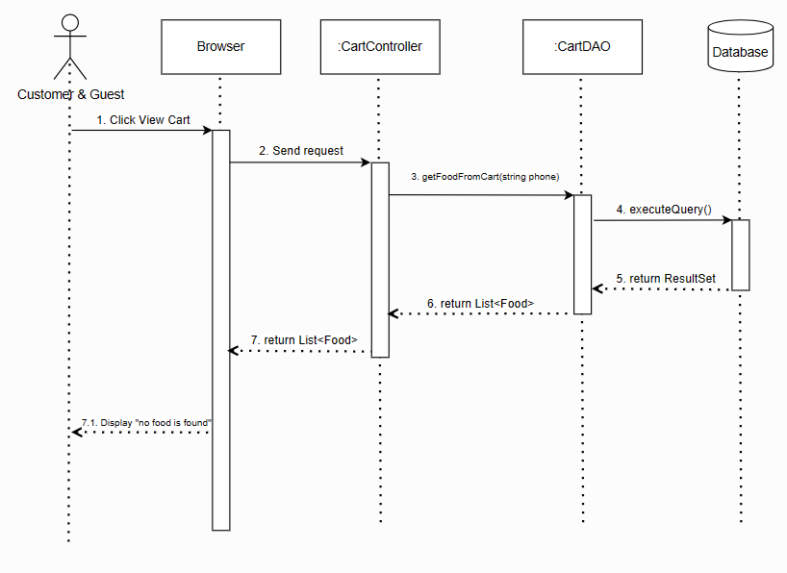

### d. Database Queries

SELECT * FROM Cart where cus_phone = ?

## 

## 3. Register for Guest

### a. Class Diagram

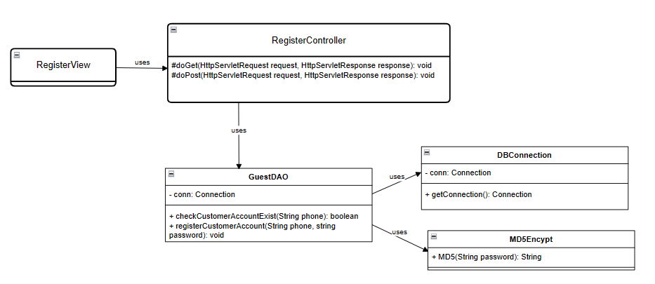

### b. Class Specifications

***DBConnection***

| **No** | **Method** | **Description** |
| --- | --- | --- |
| 01 | getConnection() | The getConnection method provides a connection to the database. It returns a Connection object to access data. |

***MD5Encrypt***

| **No** | **Method** | **Description** |
| --- | --- | --- |
| 01 | MD5(String password) | The MD5 method encrypts the password and returns the encrypted password to compare the string with the password in the database. |

***CustomerDAO***

| **No** | **Method** | **Description** |
| --- | --- | --- |
| 01 | checkAccountExist(String phone) | checkCustomerAccountExist check customer account exists in the database. If it returns true, the account exists in the database. If it returns fail, the account does not exist in the database. |
| 02 | registerCustomerAccount(String phone, string password) | registerAccount register customer account in database if account do not exist. |

### 

***CustomerController***

| **No** | **Method** | **Description** |
| --- | --- | --- |
| 01 | doGet(HttpServletRequest request, HttpServletResponse response) | The doGet method helps navigate the corresponding page based on the results of the login method. |
| 02 | doPost(HttpServletRequest request, HttpServletResponse response) | doPost method to get information from the view page, implement a register method and redirect to the corresponding page. |

### 

### c. Sequence Diagram(s)

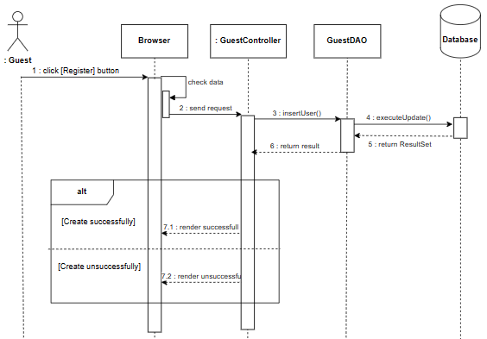

### d. Database Queries

SELECT * FROM `Customer` WHERE `cus_phone` = ?

INSERT INTO `Customer VALUES (?,?,?,?,?)

## 4. Show order history Customer

### a. Class Diagram

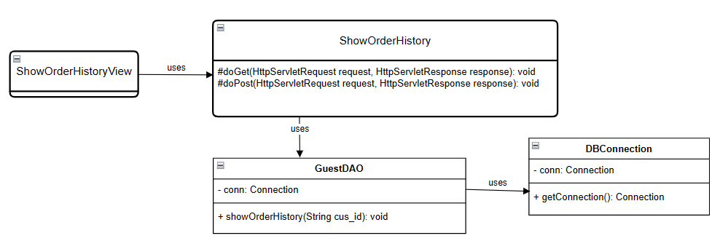

### b. Class Specifications

#### 

***DBConnection***

| **No** | **Method** | **Description** |
| --- | --- | --- |
| 01 | getConnection() | The getConnection method provides a connection to the database. It returns a Connection object to access data. |

***EmployeeDAO***

| **No** | **Method** | **Description** |
| --- | --- | --- |
| 01 | showOrderHistory(String cus_id) | The showOrderHistory method show order customer history |

### 

***EmployeeController***

| **No** | **Method** | **Description** |
| --- | --- | --- |
| 01 | doGet(HttpServletRequest request, HttpServletResponse response) | The doGet method helps navigate the corresponding page based on the results of the login method. |
| 02 | doPost(HttpServletRequest request, HttpServletResponse response) | doPost method to get information from the view page, implement a login method and redirect to the corresponding page. |

### 

### c. Sequence Diagram(s)

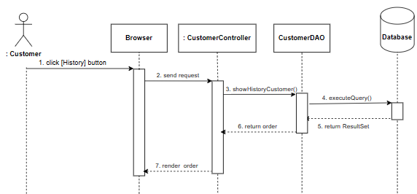

### d. Database Queries

select * from Order where cus_id = ?

## 

## 5. Login(Employee)

### a. Class Diagram

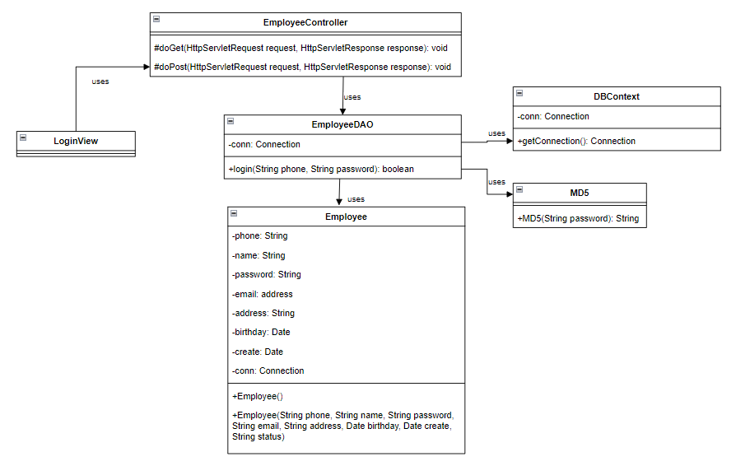

### b. Class Specifications

***DBConnection***

| **No** | **Method** | **Description** |
| --- | --- | --- |
| 01 | getConnection() | The getConnection method provides a connection to the database. It returns a Connection object to access data. |

***MD5Encrypt***

| **No** | **Method** | **Description** |
| --- | --- | --- |
| 01 | getMD5(String password) | The getMD5 method encrypts the password and returns the encrypted password to compare the string with the password in the database. |

***EmployeeDAO***

| **No** | **Method** | **Description** |
| --- | --- | --- |
| 01 | login(String phone, String password) | The login method to perform the login process. It takes a phone and password to compare with data in the database and returns the corresponding result. |

### 

***EmployeeController***

| **No** | **Method** | **Description** |
| --- | --- | --- |
| 01 | doGet(HttpServletRequest request, HttpServletResponse response) | The doGet method helps navigate the corresponding page based on the results of the login method. |
| 02 | doPost(HttpServletRequest request, HttpServletResponse response) | doPost method to get information from the view page, implement a login method and redirect to the corresponding page. |

### 

### c. Sequence Diagram(s)

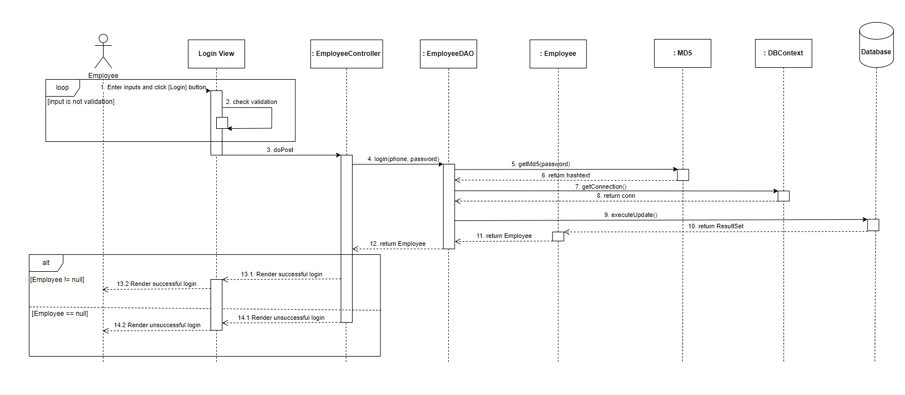

### d. Database Queries

Select * from Employee where emp_phone=? and emp_password=?

## 6. View list of orders(Employee)

### a. Class Diagram

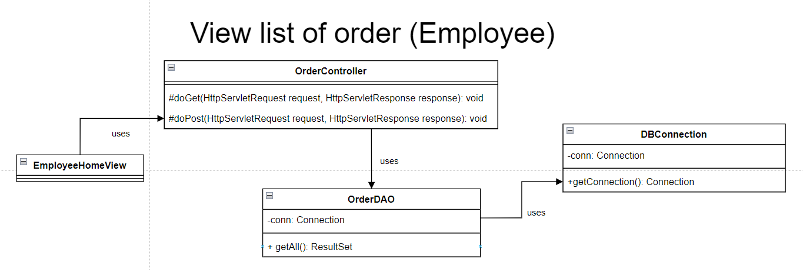

### b. Class Specifications

***DBConnection***

| **No** | **Method** | **Description** |
| --- | --- | --- |
| 01 | getConnection() | The getConnection method provides a connection to the database. It returns a Connection object to access data. |

***OrderDAO***

| **No** | **Method** | **Description** |
| --- | --- | --- |
| 01 | getOrderByEmployeePhone() | The getOrderByEmployeePhone method to get all information of orders of an employee from the database to show. |

### 

***OrderController***

| **No** | **Method** | **Description** |
| --- | --- | --- |
| 01 | doGet(HttpServletRequest request, HttpServletResponse response) | The doGet method helps navigate the corresponding page based on the results of the login method. |
| 02 | doPost(HttpServletRequest request, HttpServletResponse response) | doPost method to get information from the view page, implement a login method and redirect to the corresponding page. |

### 

### c. Sequence Diagram(s)

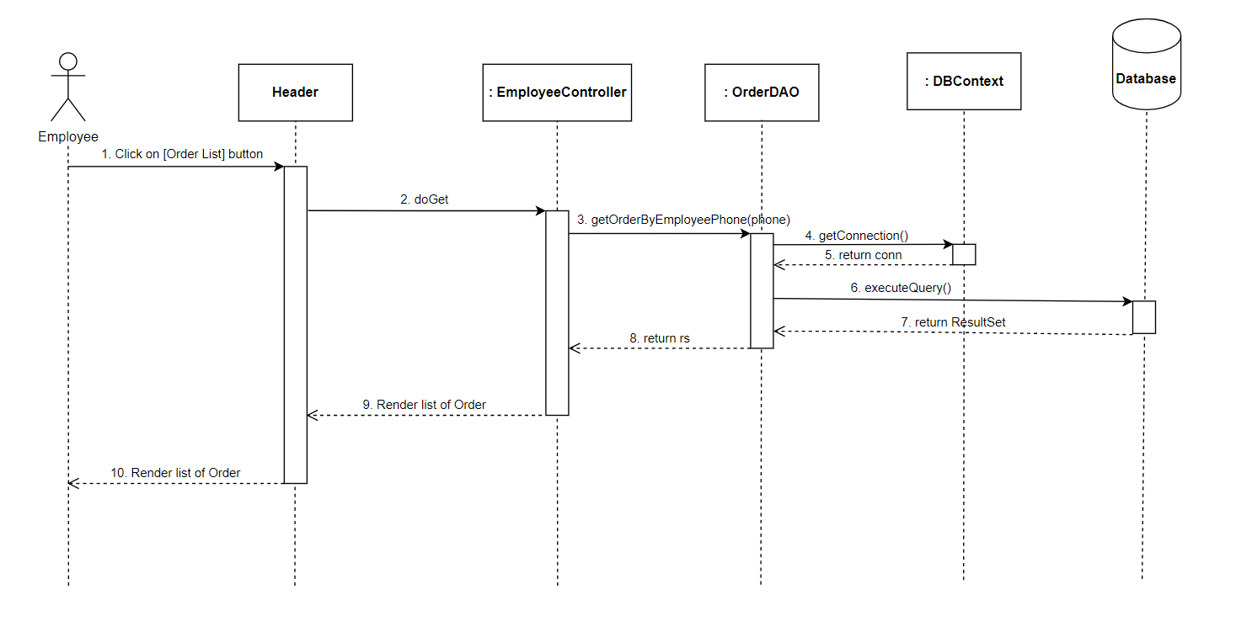

### d. Database Queries

SELECT * FROM [Order] o JOIN Customer c ON c.cus_phone = o.cus_phone WHERE o.emp_phone = ? ORDER BY CASE WHEN o.ord_status = 'waiting' THEN 1 WHEN o.ord_status = 'preparing' THEN 2 WHEN o.ord_status = 'completed' THEN 3 ELSE 4 END, o.ord_id DESC;

## 7. Change order’s status(Employee)

### a. Class Diagram

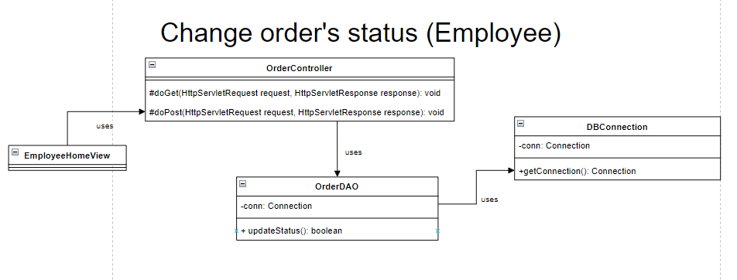

### b. Class Specifications

***DBConnection***

| **No** | **Method** | **Description** |
| --- | --- | --- |
| 01 | getConnection() | The getConnection method provides a connection to the database. It returns Connection object to access data. |

***OrderDAO***

| **No** | **Method** | **Description** |
| --- | --- | --- |
| 01 | updateOrderStatus() | The updateOrderStatus method to perform change the order’s status from employee. |

### 

***EmployeeController***

| **No** | **Method** | **Description** |
| --- | --- | --- |
| 01 | doGet(HttpServletRequest request, HttpServletResponse response) | The doGet method helps navigate the corresponding page based on the results of the login method. |
| 02 | doPost(HttpServletRequest request, HttpServletResponse response) | doPost method to get information from the view page, implement a login method and redirect to the corresponding page. |

### 

### 

### c. Sequence Diagram(s)

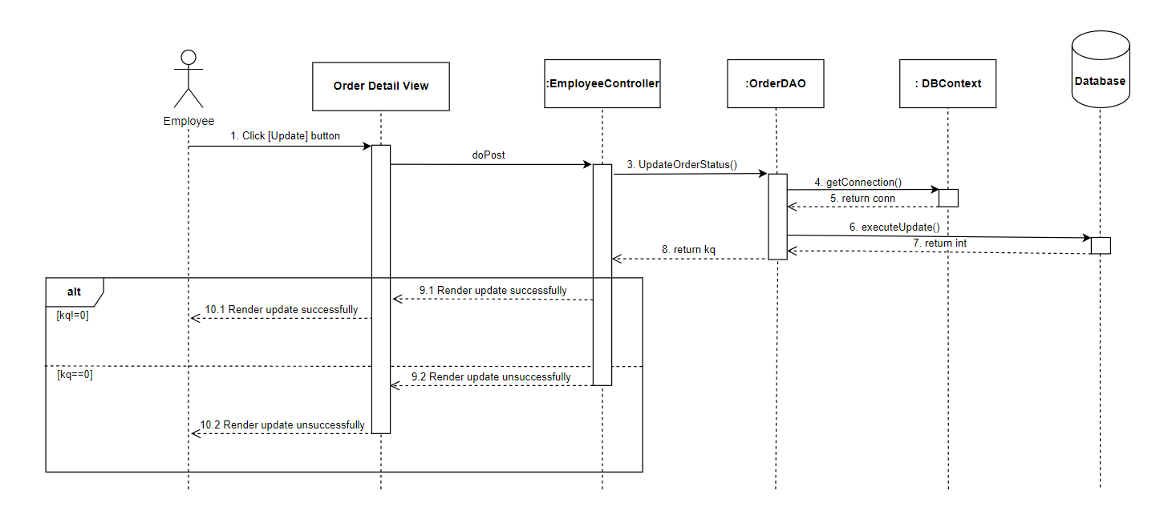

### d. Database Queries

Update [Order] set ord_status=? where ord_id=?

## 8. View order detail(Employee)

### a. Class Diagram

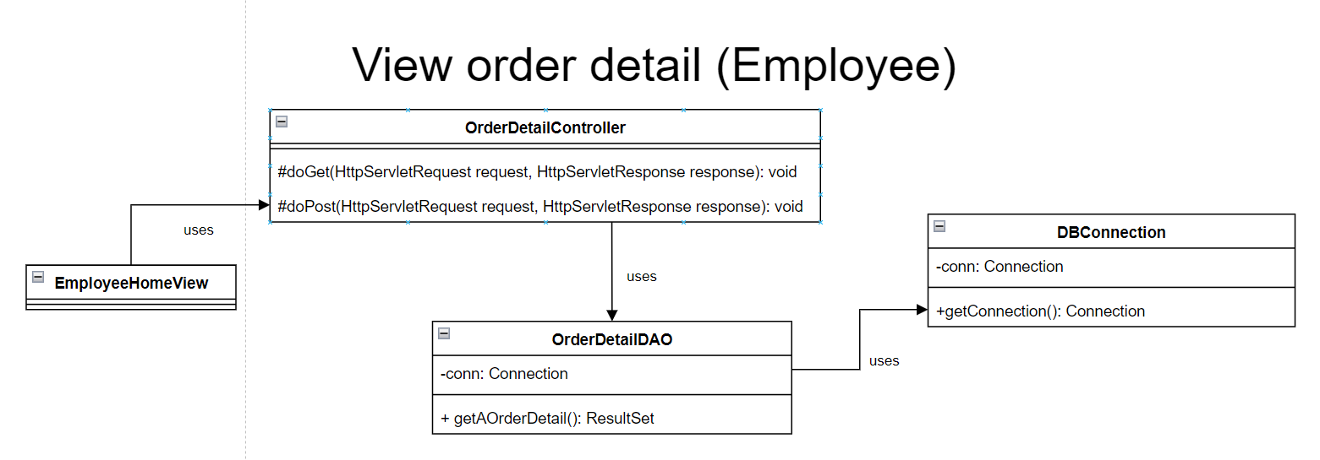

### b. Class Specifications

***DBConnection***

| **No** | **Method** | **Description** |
| --- | --- | --- |
| 01 | getConnection() | The getConnection method provides a connection to the database. It returns a Connection object to access data. |

***OrderDetailDAO***

| **No** | **Method** | **Description** |
| --- | --- | --- |
| 01 | getListOrderDetailById(String id) | The getListOrderDetailById method to get all information of an order detail from the database to show. |

### 

***OrderDetailController***

| **No** | **Method** | **Description** |
| --- | --- | --- |
| 01 | doGet(HttpServletRequest request, HttpServletResponse response) | The doGet method helps navigate the corresponding page based on the results of the login method. |
| 02 | doPost(HttpServletRequest request, HttpServletResponse response) | doPost method to get information from the view page, implement a login method and redirect to the corresponding page. |

### 

### 

### c. Sequence Diagram(s)

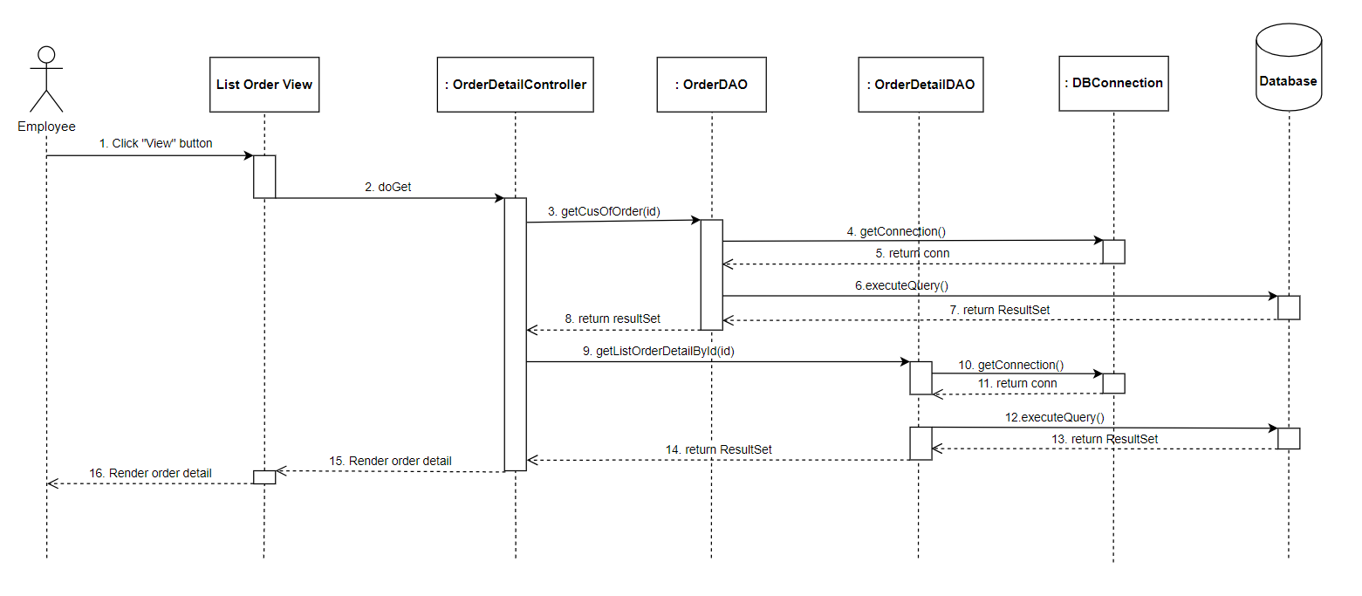

### d. Database Queries

Select * from Order_Detail where ord_id=?

## 9. View Analytics

### a. Class Diagram

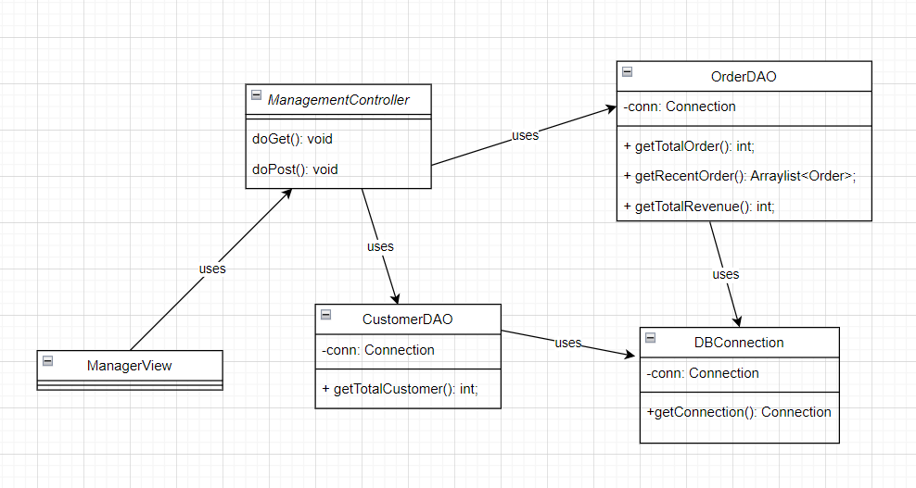

### b. Class Specifications

***DBConnection***

| **No** | **Method** | **Description** |
| --- | --- | --- |
| 01 | getConnection() | The getConnection method provides a connection to the database. It returns a Connection object to access data. |

***CustomerDAO***

| **No** | **Method** | **Description** |
| --- | --- | --- |
| 01 | getTotalCustomer() | The getTotalCustomer method to get the total number of people who have registered customer accounts |

***OrderDAO***

| **No** | **Method** | **Description** |
| --- | --- | --- |
| 01 | getTotalOrder() | The getTotalOrder method to get the total number of orders whose status has been confirmed successfully |
| 02 | getRecentOrder() | The getRecentOrder method to displays a list of the 5 most recent orders |
| 03 | getTotalRevenue() | The getTotalRevenue method to get the total amount collected from the order |

***ManagementController***

| **No** | **Method** | **Description** |
| --- | --- | --- |
| 01 | doGet(HttpServletRequest request, HttpServletResponse response) | The doGet method helps navigate the corresponding page based on the results of the login method. |
| 02 | doPost(HttpServletRequest request, HttpServletResponse response) | doPost method to get information from the view page, implement a login method and redirect to the corresponding page. |

### c. Sequence Diagram(s)

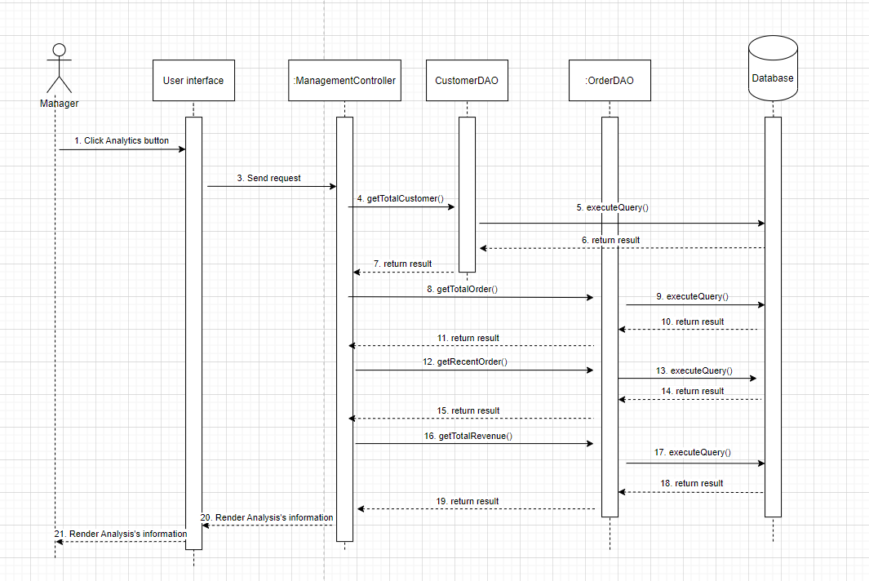

### d. Database Queries

Select count(cus_id) from Customer

Select count(ord_id) from Order

Select TOP (5) c.cus_name, ord_date, ord_status from Order o join Customer c on o.cus_id = c.cus_id

Select total(ord_total) from Order

## 10. Order Management

### a. Class Diagram

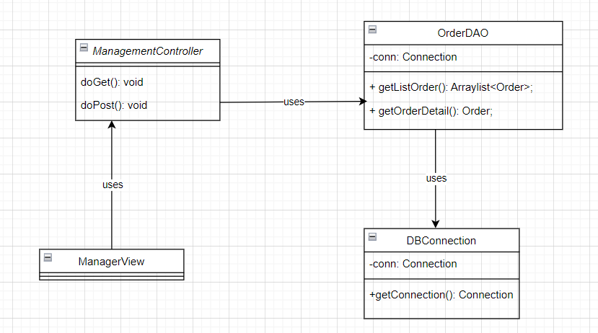

### b. Class Specifications

***DBConnection***

| **No** | **Method** | **Description** |
| --- | --- | --- |
| 01 | getConnection() | The getConnection method provides a connection to the database. It returns a Connection object to access data. |

***OrderDAO***

| **No** | **Method** | **Description** |
| --- | --- | --- |
| 01 | getListOrder() | The getListOrder method to displays a list of all orders |
| 02 | getOrderDetail() | The getOrderDetail method to displays detailed information of the order that the user has selected |

***ManagementController***

| **No** | **Method** | **Description** |
| --- | --- | --- |
| 01 | doGet(HttpServletRequest request, HttpServletResponse response) | The doGet method helps navigate the corresponding page based on the results of the login method. |
| 02 | doPost(HttpServletRequest request, HttpServletResponse response) | doPost method to get information from the view page, implement a login method and redirect to the corresponding page. |

### 

### c. Sequence Diagram(s)

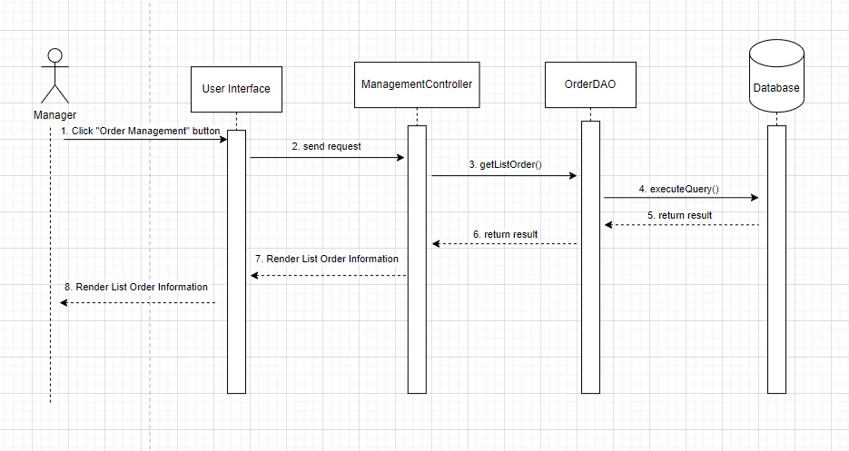

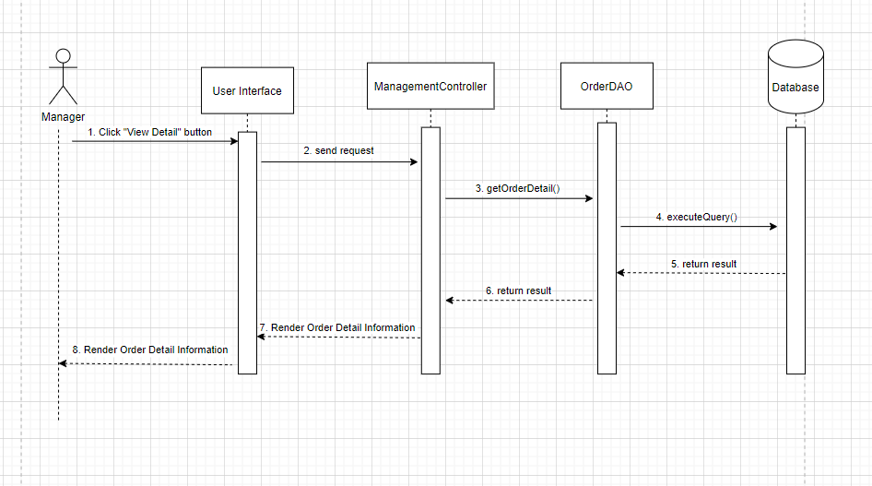

### d. Database Queries

SELECT ord_status, ord_date, c.cus_phone, ord_type, ord_total FROM Order o JOIN Customer c on o.cus_id = c.cus_id

SELECT ord_status, ord_date, ord_type, ord_note, ord_total, c.cus_phone, c.cus_name, c.cus_address, e.emp_name, d.price, d.quantity FROM Order o JOIN Customer c on o.cus_id = c.cus_id JOIN Employee e on o.emp_id = e.emp_id JOIN Order_Detail d on o.ord_id = d.ord_id WHERE o.ord_id = ?

## 11. Customer management

### a. Class Diagram

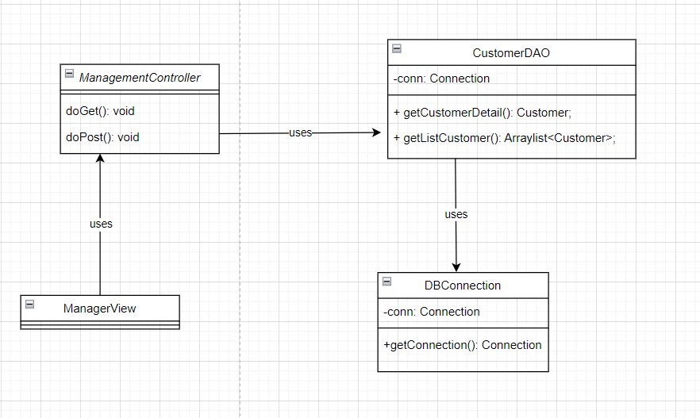

### b. Class Specifications

***DBConnection***

| **No** | **Method** | **Description** |
| --- | --- | --- |
| 01 | getConnection() | The getConnection method provides a connection to the database. It returns Connection object to access data. |

***CustomerDAO***

| **No** | **Method** | **Description** |
| --- | --- | --- |
| 01 | getListCustomer() | The getListCustomer method to displays a list of all customers |
| 02 | getCustomerDetail() | The getCustomerDetail method to displays detailed information of the customer that the user has selected |

***ManagementController***

| **No** | **Method** | **Description** |
| --- | --- | --- |
| 01 | doGet(HttpServletRequest request, HttpServletResponse response) | The doGet method helps navigate the corresponding page based on the results of the login method. |
| 02 | doPost(HttpServletRequest request, HttpServletResponse response) | doPost method to get information from the view page, implement a login method and redirect to the corresponding page. |

### 

### c. Sequence Diagram(s)

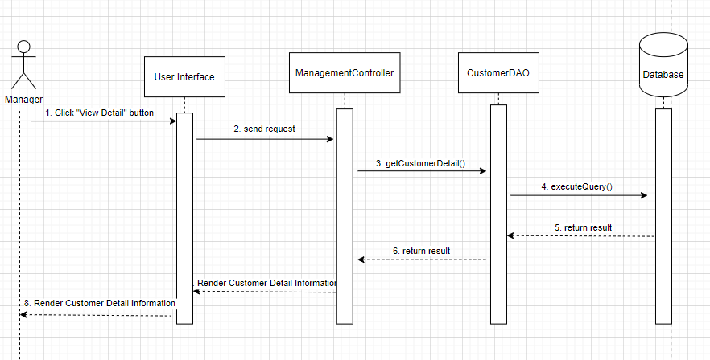

### d. Database Queries

Get all customers:

SELECT cus_name, cus_phone, cus_birthday FROM Customer

Get customer detail information:

Select count(emp_id) From Order group by emp_id

Select total(Order) from order group by cus_id

SELECT cus_name, cus_phone, cus_address, cus_birthday, order_id, order_status, order_date FROM Order o join Customer c on o.cus_id = c.cus_id WHERE c.cus_id = ?

## 12. Employee management

### a. Class Diagram

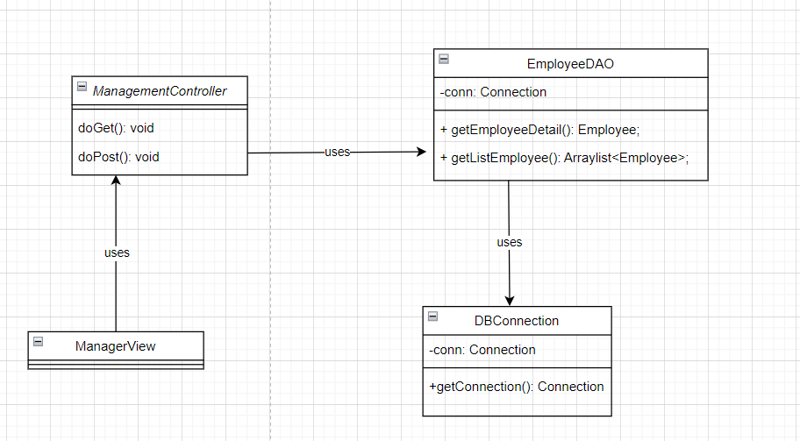

### b. Class Specifications

***DBConnection***

| **No** | **Method** | **Description** |
| --- | --- | --- |
| 01 | getConnection() | The getConnection method provides a connection to the database. It returns a Connection object to access data. |

***CustomerDAO***

| **No** | **Method** | **Description** |
| --- | --- | --- |
| 01 | getListEmployee() | The getListEmployee method to displays a list of all employees |
| 02 | getEmployeeDetail() | The getEmployeeDetail method to displays detailed information of the employee that the user has selected |

***ManagementController***

| **No** | **Method** | **Description** |
| --- | --- | --- |
| 01 | doGet(HttpServletRequest request, HttpServletResponse response) | The doGet method helps navigate the corresponding page based on the results of the login method. |
| 02 | doPost(HttpServletRequest request, HttpServletResponse response) | doPost method to get information from the view page, implement a login method and redirect to the corresponding page. |

### c. Sequence Diagram(s)

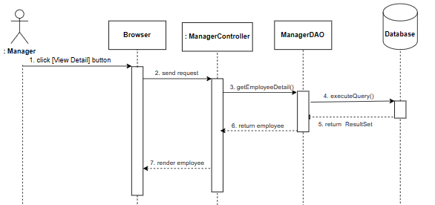

### d. Database Queries

Get all employees:

SELECT emp_name, emp_phone, emp_birthday FROM Employee

Get employee detail information:

SELECT emp_name, emp_phone, emp_address, emp_birthday, order_id, order_status, order_date FROM Order o join Employee e on o.emp_id = e.emp_id WHERE e.emp_id = ?

### 